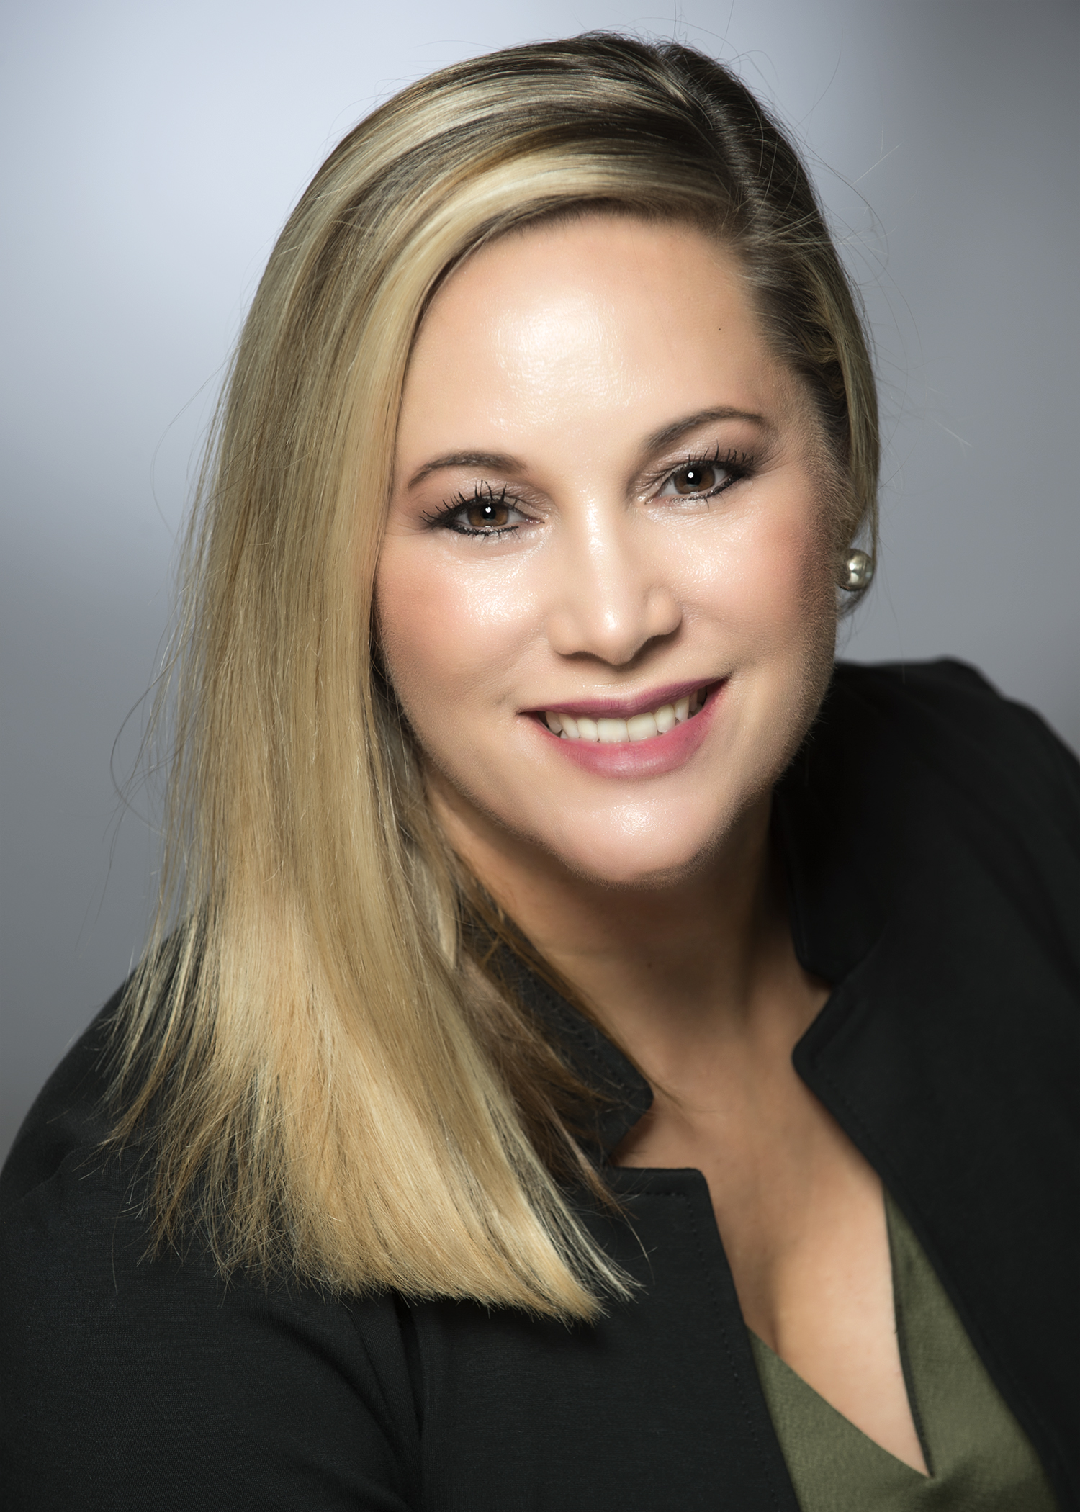
Tammy Browning
President, KellyOCG

Tammy Browning is president of KellyOCG®. She’s responsible for the company’s $12 billion global MSP portfolio, which includes embedded solutions such as services procurement, payroll outsourcing, the global RPO practice, and the Ayers Group outplacement. KellyOCG partners with some of the largest organizations in the world including many of the Fortune 500®.

Her path to executive leadership started more than 20 years ago with a temporary role as a candidate coordinator with Kelly®. Demonstrating a skill for visionary thinking, combined with a passion for operational excellence, Tammy held several customer- and talent-facing manager roles across the business—eventually leading the west territory and IT practice for the company’s U.S. staffing operations. In 2010, she joined a supplier to Kelly as senior vice president responsible for all U.S. operations before returning to Kelly in 2017 with additional expertise and expanded oversight. Tammy’s 360-degree view of business operations provides her with a unique level of insight that continues to shape her leadership style today.

She’s passionate about the opportunity to change lives and provide purpose by connecting people to meaningful work. Tammy is inspired by the extraordinary stories of the people her team impacts and their ability to help customers realize the value of all workstyles. She brings a pioneering spirit to internal and external challenges. This approach to do things differently extends across every part of the KellyOCG business. Tammy is always looking for new ways to add value for her customers by helping them discover what’s next in the world of work and is recognized for her ability to spark change through forward-looking solutions.

Tammy is an industry thought leader—regularly sharing her insights on the ways people want to engage with work today and how organizations can meet their workforce challenges of the future. Staffing Industry Analysts® recognized Tammy as one of the most influential leaders in the staffing industry, naming her to its “Staffing 100” and "Global Power 150" Women in Staffing lists since 2020. Inspiring Workplaces named Tammy a 2021 Inspiring Leader for being inclusive, courageous, transparent, and empowering. Diversity Journal also recognized Tammy’s strong leadership efforts and named her a 2020 “Women Worth Watching” award recipient.

Tammy is a well-seasoned and self-proclaimed “travel sports mom.” In her free time, you can find her spending time with her family and spoiling her grandchildren.

